Competitive Shooters of Lake Norman USPSA February 19th, 2026
COURSE DESIGNER: Ike Starnes
START POSITION: See written stage briefings.

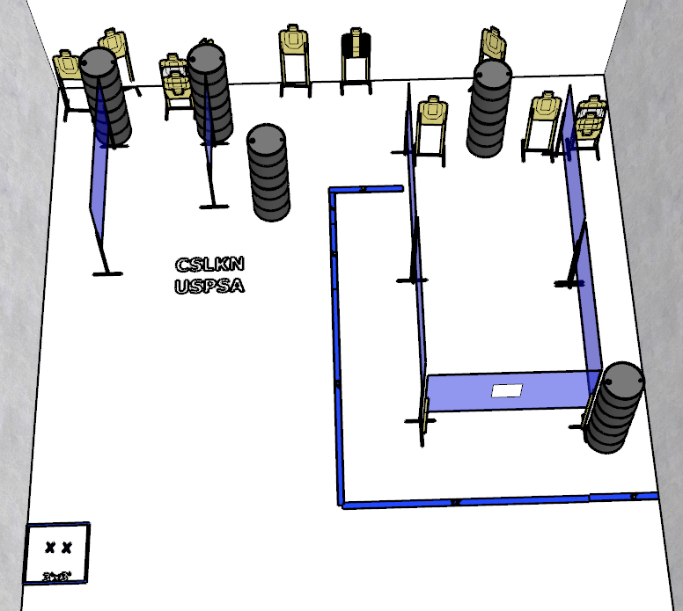

Written Stage Briefing:

Stage 4 – Can I copy your homework
24 rounds, 120 points, Comstock
There are 11 cardboard targets and some noshoots. The best 2 hits per cardboard target will be scored.
Handgun start position Feet on Xs. The handgun is loaded and holstered.
PCC start position Feet on Xs. PCC is loaded with stock touching belt.
On the audible start signal, engage targets from within the shooting area.

